**Exercise 5: Return Data from a Stored Procedure**

**Goal: Create a stored procedure that returns the total number of employees in a**

**department.**

**Steps:**

**1. Define the stored procedure with a parameter for DepartmentID.**

**2. Write the SQL query to count the number of employees in the specified department.**

**3. Save the stored procedure by executing the Stored procedure content.**

CREATE PROCEDURE sp_GetEmployeeCountByDepartment

@DepartmentID INT

AS

BEGIN

SELECT

COUNT(*) AS TotalEmployees

FROM Employees

WHERE DepartmentID = @DepartmentID;

END;

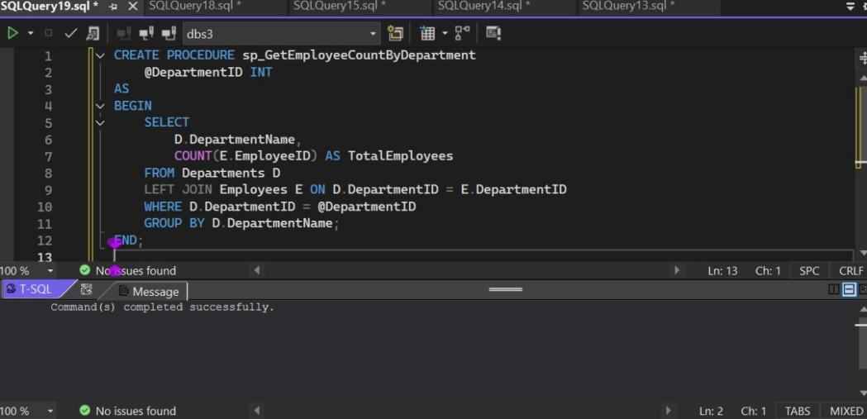

EXEC sp_GetEmployeeCountByDepartment @DepartmentID = 3;

